**1.background**

**Use airline industry to explain the correlation relationship**

**Major airline(three major)**

**Oil 每年用多少钱**

**1.Delta airline data**

(1) initial data

Here we collected data from yahoo finance on Delta Airline’s daily stock adjust close price from May 2010 to May 2016 (6 years). Totally, we have 1531 data.

Chart1: Delta airline daily stock price

Reference: <http://finance.yahoo.com/q/hp?s=DAL>

(2)Data description（三个表合并）

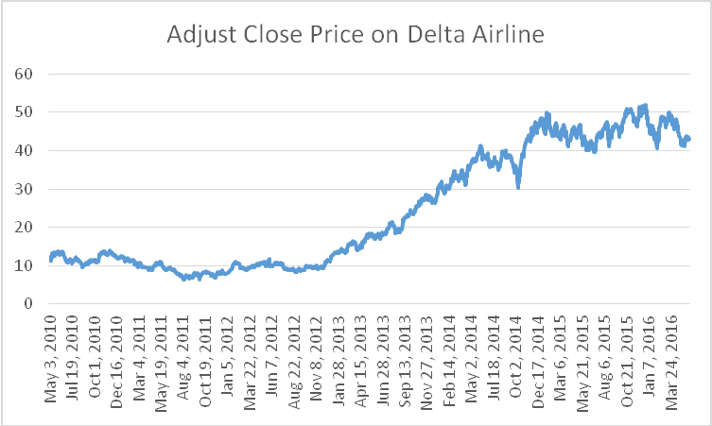

Chart2: Adjust Close Price on Delta Airline Line Chart（不用讲）

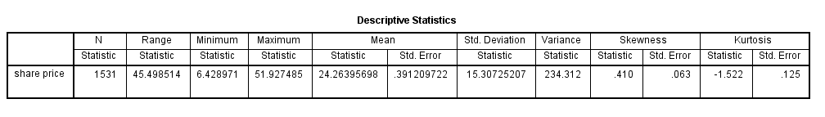

Chart3: Descriptive Statistics on the Adjust Close Price of Delta Airline

The mean value of Delta Airline stock from May 2010 to May 2016 is 24.26395698. Also the variance is 234.312, which suggest the data is not around the mean. Experimental value of the skewness is 0.410, which means the mass of the distribution is concentrated on the left of the figure. Kurtosis of the data is -1.522, which indicated that the curve is flat and has longer tails on both side (The Kurtosis of normal distribution is 0. )

**2. Crude oil price data**

(1) Initial data

Here we will collect data from US. Energy Information Administration on West Texas Intermediate (WTI) crude oil price from May 2010 to May 2016 (6 years)

Reference: <http://www.eia.doe.gov/dnav/pet/TblDefs/pet_pri_spt_tbldef2.asp>

(2)Data description

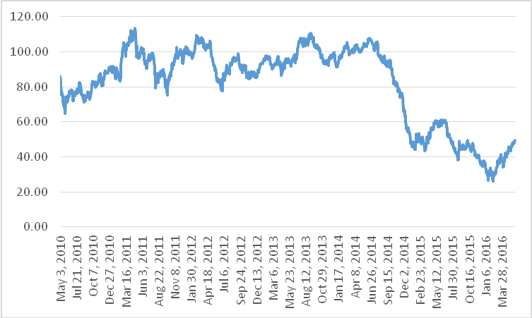

Chart5: Line Chart of Crude oil price

Chart6: Descriptive Statistics on the Crude Oil Price

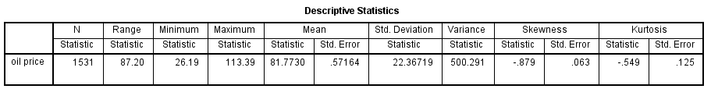

The mean value of crude oil price from May 2010 to May 2016 is 81.7730. Also the variance is 500.291, which suggest the data is not around the mean. Experimental value of the skewness is-0.879, which means the mass of the distribution is concentrated on the right of the figure. . Kurtosis of the data is -0.549, which indicated that the curve is slightly flat and has a little bit longer tails on both side (The Kurtosis of normal distribution is 0. )

**3. Correlation Test**

(1) Chart5:Line Chart of Crude oil price and delta airline

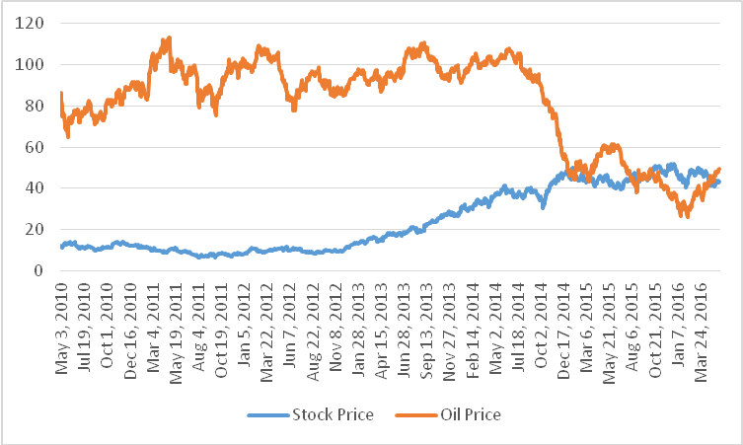

Delta stock price: As we can see in the chart, from May 2010-January 2013, the share price was relatively steady. After January 2013, the share price went up sharply.

Crude oil price: From May 2010-May 2014, the price was fluctuated. After May 2014, the price went down sharply,

(2) pearson correlation test (linear correlation)（what is r; how to get r）

We use pearson correlation test to find the correlation relationship between Delta Airline Price and crude oil price.

|  |  |  |  |
| --- | --- | --- | --- |
| **Chart7:Pearson Correlations Test** | | | |
|  | | Stock Price | Oil Price |
| Stock Price | Pearson Correlation | 1 | -.687** |
| Sig. (one-tailed) |  | .000 |
| N | 1531 | 1530 |
| Oil Price | Pearson Correlation | -.687** | 1 |
| Sig. (one-tailed) | .000 |  |
| N | 1531 | 1531 |
| **. Correlation is significant at the 0.05 level (one-tailed).  According to Chart7, the pearson correlation is -0.687 and also the P value is smaller than the significant number 0.05. So, the conclusion is the crude oil price and the delta airline stock prices have the negative correlation relationship.  **4. regression line Model**  (1) Notation definition   |  |  |  | | --- | --- | --- | | Notation | Value | Unit | | X | Crude oil price | Dollar | | D | Delta Airline Share Price | Dollar |     (2) Assumption  a. We use the logarithm regression line to describe the relationship between two variables.  b. Crude oil price is the independence variable; Delta Airline Share adjust closed price is the dependence variable.  c.The model we set up is ( is constant number, is coefficient of ln(x),) | | | |

(3) Estimate model

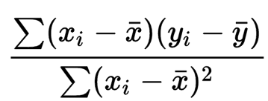

=

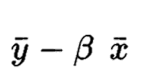

=



|  |  |
| --- | --- |
| {\displaystyle {\bar {x}}}x | observed value independence variable |
|  | observed value dependence variable |
|  | Mean value of independence variable |
|  | Mean value of dependence variable |

For more convenience, we use the spss sofeware to estimate the regression line.

Chart: coefficient result

|  |  |  |  |  |
| --- | --- | --- | --- | --- |
|  | Unstandardized Coefficients | | t | Sig. |
| Coefficient | Std. Error |
|  | -32.248 | .819 | -39.363 | .000 |
|  | 164.700 | 3.578 | 46.026 | .000 |

（Use the standard error of the coefficient to measure the precision of the estimate of the coefficient. The smaller the standard error, the more precise the estimate.）

Chart: Scatter Plot

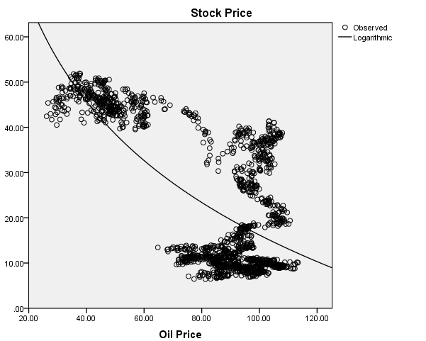

|  |  |  |
| --- | --- | --- |
| R | R Square | Std. Error of the Estimate |
| .709 | .503 | 10.791 |

Chart: The coefficient of determination

Conclusion1:The coefficient of determination(R Square)=0.503. This means that 50.3% of variation in Delta Airline’s share price can be explained by variation in Crude oil price.

Conclusion2:Because is -32.248, which means every 1 unit change in the natural log of oil price can cause 32.248 unit change in the natural log of share price. Oil price does big contribution to the Delta Airline share price



(4) Hypothesis testing

|  |
| --- |
|  |

a. The null hypothesis: The is 0.



The alternative hypothesis: The coefficient is less than 0.

b. We need to compare t value to the critical value

t=(coefficient-0)/standard error

c.=(-32.248-0)/0.819=-39.363;



d. The probability level is 0.05. The freedom of degree is 1531*2-2=3058. The critical value for one tail is -1.96074008. So, the critical region is less than -1.96074008. T value -39.363 is in the critical region. We need to reject the null hypothesis and accept the alternative hypothesis.

e. Coefficient range

As we know, the model is estimate model, so we can find the 95% confidence intervals for the coefficient range

= -32.2480.819*1. 96074008= (-33.85384613,-30.64215387)



=164.6483.582*1. 96074008= 157.62462903, 171.67137097)



**5. American airline data**

(1) Initial data

Here we will collected data from yahoo finance on Delta Airline’s daily stock adjust close price from May 2010 to May 2016 (6 years). Totally, we have 1531 datas.

Reference: [http://finance.yahoo.com](http://finance.yahoo.com/q/hp?s=DAL)

(2) Correlation test

Chart5:Line Chart of Crude oil price and American airline stock price

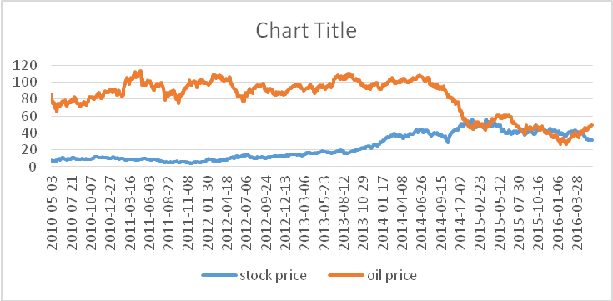

(3) pearson correlation test (linear correlation)

We use pearson correlation test to find the correlation relationship between American Airline Price and crude oil price.

|  |  |  |  |
| --- | --- | --- | --- |
| **Chart7:Pearson Correlations Test** | | | |
|  | | Stock Price | Oil Price |
| Stock Price | Pearson Correlation | 1 | -.62** |
| Sig. (one-tailed) |  | .000 |
| N | 1531 | 1530 |
| Oil Price | Pearson Correlation | -.612** | 1 |
| Sig. (one-tailed) | .000 |  |
| N | 1531 | 1531 |
| (4) **regression line Model**  a. notation   |  |  |  | | --- | --- | --- | | Notation | Value | unit | | X | Crude oil price | Dollar | | A | American Airline Share Price | Dollar |   b.model  Chart: coefficient result   |  |  |  |  |  | | --- | --- | --- | --- | --- | |  | Unstandardized Coefficients | | t | Sig. | | Coefficient | Std. Error | |  | -28.745 | .917 | -31.348 | .000 | |  | 148.598 | 4.005 | 37.102 | .000 |      |  |  |  | | --- | --- | --- | | R | R Square | Std. Error of the Estimate | | .625 | .391 | 12.078 |   **6.Southwest airline**  (1)correlation test  Chart: Line Chart of Crude oil price and Southwest airline stock price   |  |  |  |  | | --- | --- | --- | --- | | **Chart7:Pearson Correlations Test** | | | | |  | | Stock Price | Oil Price | | Stock Price | Pearson Correlation | 1 | -.782** | | Sig. (2-tailed) |  | .000 | | N | 1531 | 1530 | | Oil Price | Pearson Correlation | -.782** | 1 | | Sig. (2-tailed) | .000 |  | | N | 1531 | 1531 |   (2)regression line Model  a. notation   |  |  |  | | --- | --- | --- | | Notation | Value | unit | | X | Crude oil price | Dollar | | S | Southwest Share Price | Dollar |   b.model   |  |  |  |  |  | | --- | --- | --- | --- | --- | |  | Unstandardized Coefficients | | t | Sig. | | Coefficient | Std. Error | |  | -31.239 | .610 | -51.192 | .000 | |  | 157.237 | 2.665 | 58.992 | .000 |   Chart: coefficient result   |  |  |  | | --- | --- | --- | | R | R Square | Std. Error of the Estimate | | .795 | .632 | 8.038 | | | | |

**7. Compared three models**

(1)Three major companies line chart

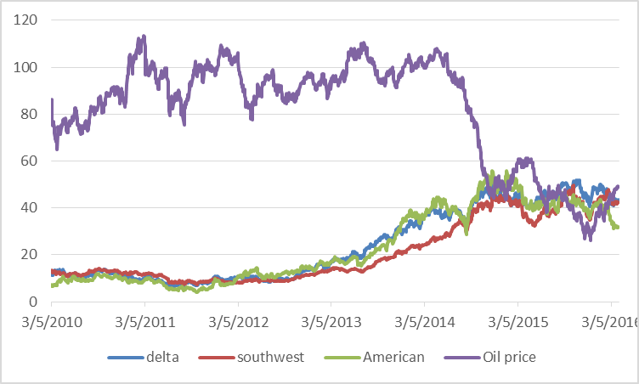

According to this chart, the stock prices of the airline industry have the opposite tendency with the oil price. Obviously, Starting from May 2014, the oil price went down in the past two years and the stock price went up in the past two years.

(2)Model comparison

Delta Airline:

American Airline:

Southwest Airline:

We can see, those three models have similar coefficients. differs from -28.745 to – 32.248. We can get the conclusion that: Oil price is the common factor to affect the stock price of the airline industry. When the oil price goes up, it may cause the stock price of the airline industry decreasing. Oppositely, when the oil price dropped, it can cause the stock price of the airline industry increasing.（涉及R）

